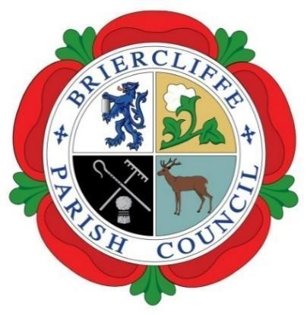
Briercliffe with Extwistle Parish Council

ANNUAL PARISH MEETING.

Thursday 14th May 2026 at 7.30pm at Briercliffe Community Centre.

Present: Councillors Roger Frost, Pippa Lishman Gordon Lishman and Carrie Halstead,
Incoming Councillors Samual Phillips, Nicola Harvey, Alison Griffin and Maggie Lishman.

In Attendance: Councillor Anne Kelly, R Greenwood (Clerk) 8 members of the public.

The Chair, Councillor Roger Frost opened and welcomed all to the meeting. Members were reminded that the meeting was being recorded for accuracy of the minutes and training.
 | Actions by Clerk | Cllr Support
26/27/024 Apologies for absence
Apologies were received and accepted from County Councillor Mark Poulton.

26/27/025 Disclosable Pecuniary Interest
No Councillors declared any pecuniary interest.
Councillors completed their Register of Interest Forms, Acceptance of Office and Code of Conduct forms.

26/27/026 Minutes of the meeting held May 2025
The minutes of the meeting held May 2025 were accepted and signed as a true record.

26/27/027 Chairs report for the municipal year 2025/26 – partial year only.
Cllr Roger Frost presented his report stating that he had only been in post for 6/7 months taking over after the resignation of Cllr Michael McFarlane. The term had come with its own challenges and Cllr Frost wished to thank members and the clerk for their support.

Cllr Frost gave a financial precis stating that the Precept had been increased to facilitate new spending, the allotment and garage rent would be increased in 27/28. It was explained that the garages, garage sites and allotments provide an income stream which is spent on maintenance of those, with additional income being received from the Precept.

The largest expenses to the Parish Council are the clerk’s salary and the Lengthsman’s contract – this taking up most of the Precept which had not kept pace with inflation. Other expenses included Christmas decorations, and the buying plants for the village. The current Parish Council is working within its financial means.
Cllr Frost stated that the country is in a period of change due to the Local Government Reform in which the County and Borough Councils will disappear but the Parish Council will remain.

Other works completed during this Chair-ship is the Woodland Walk project, this has concentrated on works to fell tree’s suffering from Ash Die back. This is a 5 year project and Former Cllr Michael Greenwood and the Lengthsman were thanked for their work.

Cllr Frost announced that a Heritage Event would be run in September, a working group would be set up and there would be speakers and refreshments.

Lastly Cllr Frost thanked members for their support and hoped that his successor would receive the same level of support.

26/27/028 Financial report for the municipal year 2025/26
Cllr G Lishman explained that the Precept had been increased by £2,000 for the forthcoming year, that the rental increase for the garages and allotments had been agreed at 5% and that the notice for this will go out with the forthcoming invoices. Cllr G Lishman also clarified only the Clerk was salaried that the Lengthsman is a contractor.

The RFO said that the accounts were ready to go to Audit and that financial year 25/26 had been reconciled and closed for both the Scribe accounts package and the wages package.

26/27/029 Date of the next Annual Parish Meeting.
The date for the next Annual Parish Meeting will be Thursday 13th May 2027, not the 8th May 2027 as this is election week.

